Pooled models and age effects

The following analyses were meant to determine where the age pattern of hearing loss kinks between child and older age hearing loss. All of the following analyses were done using only the subset of studies with reasonably complete age patterns (study IDs 2 4 5 8 15 21 40 41 42 43 47 3 13 32 33).

The basic model used was a logistic regression:

Logit(prev) ~ mean_age, age/log(gdp) interaction term, age/threshold interaction term, sex, threshold, log(gdp)

All observations were aweighted by 1/sqrt(n) to counteract the larger weight a logistic regression gives to larger studies.

All code is here: X:\GBD2005\DISABILITY ENVELOPES\Hearing loss\Gretchen R modeling\age cutoff\check age patterns with dummies.do

Using dummies to determine where the kink is

When dummies were added to the basic model, all were significant through the 35-44 age group. Fitted dummy coefficients' 95% CIs were:

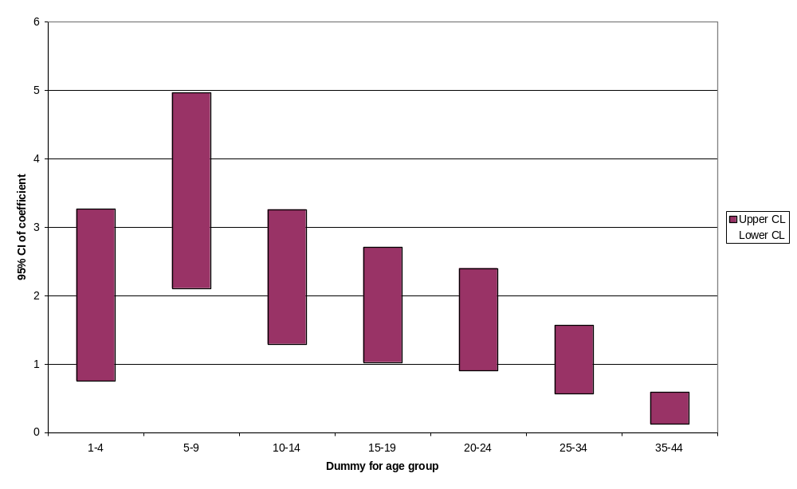
Since age was still included as a continuous variable, this translates into age-predictions that look like this in logit space (for a hypothetical middle-income mixed-sex group):

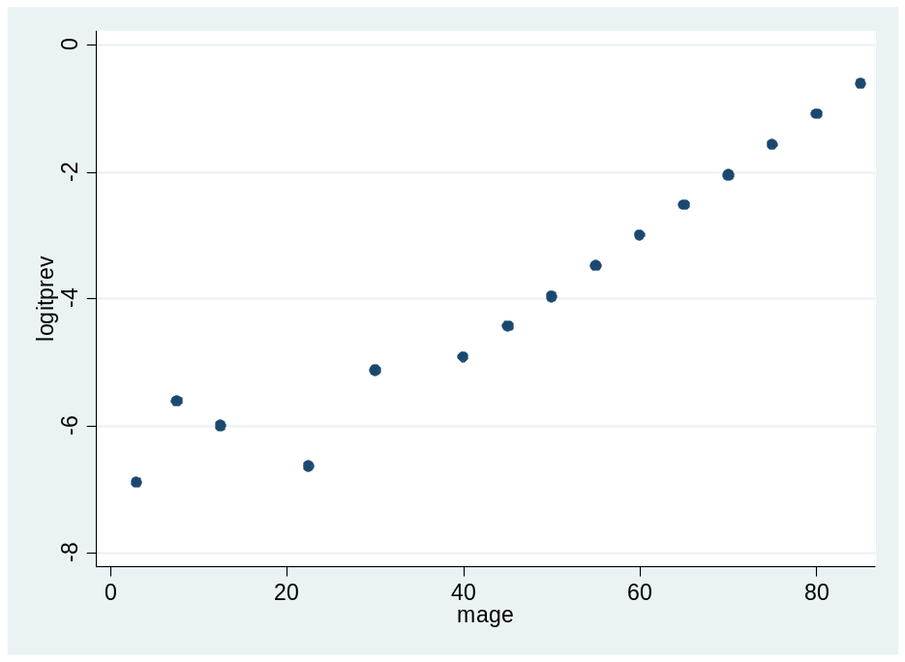

Using spline to determine where the kink is

This table shows the AIC and BIC when a 2-piece spline is used, with the kink located at different ages:

Age where kink is | AIC | BIC | young coeff | old coeff
10 | 2.99 | -5738 | -0.16 | 0.04
15 | 2.96 | -5773 | -0.1 | 0.06
25 | 2.91 | -5826 | -0.02 | 0.07
35 | 2.88 | -5867 | 0.02 | 0.09
40 | 2.87 | -5874 | 0.034 | 0.09
45 | 2.86 | -5885 | 0.046 | 0.01
50 | 2.87 | -5876 | 0.06 | 0.1

Lowest AIC and BIC are best, so the best fit is when the kind is at age 45. This was also true if the interaction terms were given kinks at the same age, and when the interaction terms were removed altogether, and when infants were removed (as infants have much lower prevalence than the rest of children).

Having the kink at age 45 still presupposes a continuous (logistic) age pattern during the 0-44 age range. If the younger age group is given no age pattern (in a model with all age interactions removed), the best fit is when the division is at age 35.

These graphs can be used to check whether we think the logistic - age pattern assumption is OK for under 45. It seems OK to me with a bit of weirdness in the under-20 range.
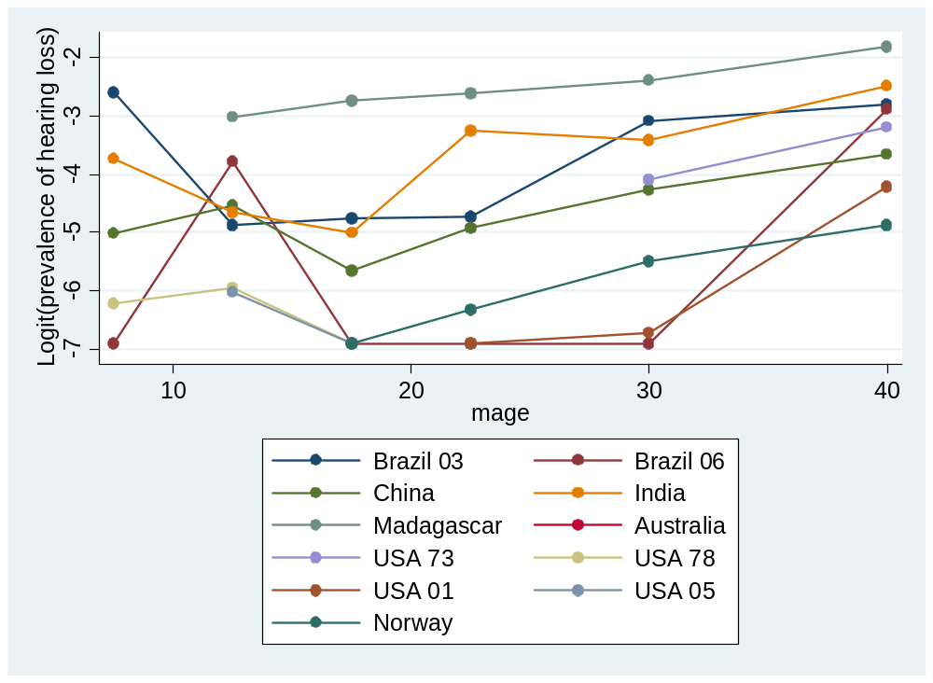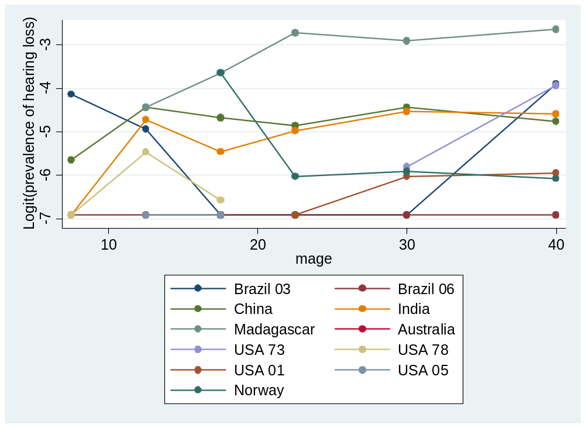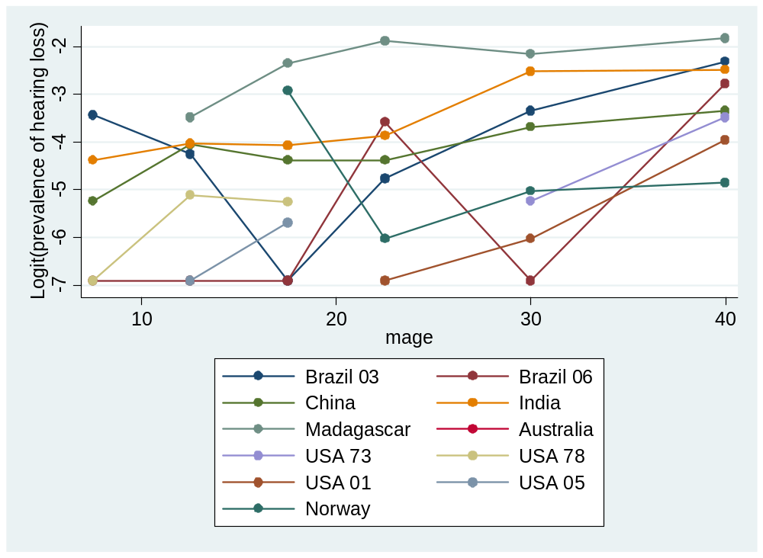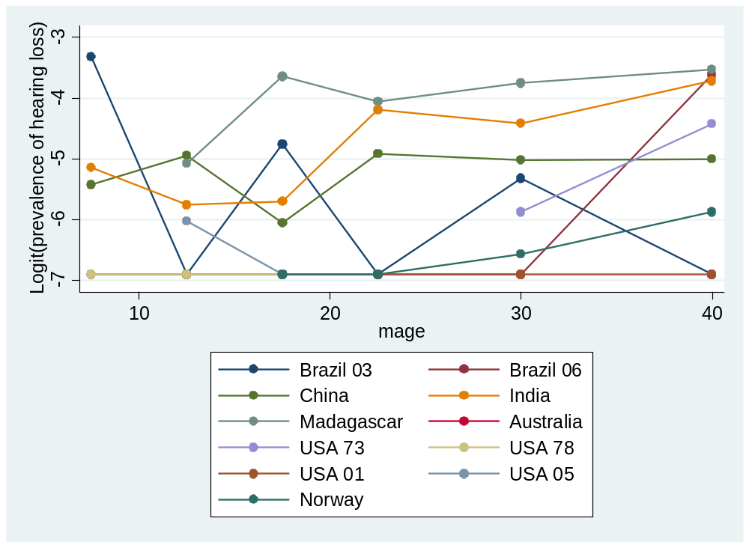

Testing whether the kinks vary by threshold: this table shows AICs. Red shows the "best" kink.

Age where kink is | 35 db | 50 db | 65 db | 80 db
35 | 5.095167
45 | 5.093395 | 3.802067 |  | 2.007076
55 | 5.124995 | 3.77779 | 2.38163 | 2.001196
65 |  | 3.782949 | 2.369604 | 2.004478

